Notice of local participatory event on beneficial ownership transparency in Spain

  - Preparatory action – Capacity building programmatic development and communication in the context of the fight against money laundering and financial crimes￼







Internal document:
Report of local participatory event on beneficial ownership transparency in Spain
Prepared by Transparency International España


Civil Society Advancing Beneficial Ownership Transparency (CSABOT) is a project that implements the Preparatory Action – Capacity Building Programmatic Development and Communication in the Context of the Fight against Money Laundering and Financial Crimes. This project is performed by Transparency International Secretariat (TI-S), together with Tax Justice Network (TJN), Transcrime – Università Cattolica del Sacro Cuore (Transcrime – UCSC) and the Government Transparency Institute (GTI), under a contract with the European Union represented by the European Commission. The opinions expressed are those of the contractors only and do not present an official view of the European Commission.

Summary of local event in Spain

The local event in Spain, entitled “La transparencia de la titularidad real en España: Hacia un registro nacional de titulares reales transparente y efectivo” (Beneficial Ownership Transparency in Spain: Towards a transparent and meaningful national register of beneficial owners), took place on 23th september 2022, from 9 to 14 pm, in Madrid, at the Conference Hall of Registro de la Propiedad de Madrid. It was organised by Transparency Internationa Spain (TI Spain), TI’s local national chapter in Spain.
The main objective of the Seminar was to raise awareness about how money laundering and terrorism financing risks are related primarily to the lack of beneficial ownership transparency and to identify best practices of central registries in Europe to allow local stakeholders to draw lessons and recommendations on how to improve beneficial ownership transparency in Spain.
As the main goal of the event was to raise public awarness on the need for beneficial ownership transparency, it was organised as an open hybrid event (both in person and online). 11 national and international speakers and 3 moderators participated in the event, in person and virtually (see Annex VI: Short bio of speakers). It was structured around three roundtables respectively focusing on the status of beneficial ownership transparency in Spain, beneficial ownership transparency in Europe and the role of civil society to advance beneficial ownership transparency. (See Annex I: Full programme of the event). A summary of the outcome of the discussions is presented below the Discussion & Recommendations section.
To promote the event, TI Spain reached out to local coalitions active in relevant fields such as the Coalition for Access to Information (CPA), who in turn sent out invitations to their members. Invitations have also been sent to the academic institutions partnering with TI Spain within the framework of TI Spain Internship Program, who promoted the event among their students. The event was also promoted to a wider audience through social media networks.
As an outcome of these outreach efforts, 135 participants registered for the event, out of which 47 attended in person and 53 attended online as follows (see Annex II: Full list of registered participants):

Sector | Actual Participants | Confirmed (potential) participation | Individuals invited | Organizations and institutions contacted
Civil society | 5 in person  2 online | 14 | 32 | 6
Media | 1 in person | 0 | 314 | 85
Academia | 4 in person  2 online | 10 | 35 | 10
Public sector | 23 in person  22 online | 45 | 124 | 57
Private sector | 13 in person  23 online | 51 | 319 | 50
Other | 1 in person  4 online | 15 | 23
Total | 47 in person  53 online | 135 | 847 | 208

Communications

The main objective of the webinar was to raise public awareness on how money laundering and terrorism financing risks are related to the lack of beneficial ownership transparency. For this reason, the event was organised as an open event to reach as many people as possible and communications plans were designed accordingly. At the same time, TI Spain also targeted experts and organisations with an expertise in in the subject matter through their existing networks and those of partner organisations.
Pre-event promotion plan
The pre-event communication strategy was based on two fundamental pillars: communication targeting the general public and personalised communication targeting an audience of experts and practitioners.
The invitation process was implemented following three steps:
- First, TI Spain created a list of individuals and organisations who could be interested in the event’s topic area with the concern of ensuring a balanced representation of all sectors.
- Secondly, TI Spain sent targeted invitations to their existing networks, using Transparency International Spain's databases.
- Finally, TI Spain promoted the event shortly before it took place in the local media and through social media.
For the public promotion of the event, the local partner first developed a series of visual materials (program and flyers) and a social media kit. Before the event, TI Spain published a total of 12 tweets, a post on LinkedIn as well as a news item on their website and in their Newsletter (see table below).

Channel | Total impressions | Interactions | Link
Twitter | 6975 | 74 | https://twitter.com/TISpain/status/1569721629747384320?s=20&t=PafR2joidOwaJbWoHwWxnQ  https://twitter.com/Registrador_es/status/1570009893041590272?s=20&t=PafR2joidOwaJbWoHwWxnQ  https://twitter.com/TISpain/status/1570745235109740544?s=20&t=PafR2joidOwaJbWoHwWxnQ  https://twitter.com/TISpain/status/1570745246870556673?s=20&t=PafR2joidOwaJbWoHwWxnQ  https://twitter.com/TISpain/status/1571896882041061377?s=20&t=PafR2joidOwaJbWoHwWxnQ  https://twitter.com/TISpain/status/1571896884205158401?s=20&t=PafR2joidOwaJbWoHwWxnQ  https://twitter.com/TISpain/status/1572635769096765443?s=20&t=PafR2joidOwaJbWoHwWxnQ  https://twitter.com/TISpain/status/1572635771592675329?s=20&t=PafR2joidOwaJbWoHwWxnQ  https://twitter.com/anticorruption/status/1572902986694725632?s=20&t=PafR2joidOwaJbWoHwWxnQ  https://twitter.com/TISpain/status/1572971355443953665?s=20&t=PafR2joidOwaJbWoHwWxnQ  https://twitter.com/Registrador_es/status/1573201748612861952?s=20&t=PafR2joidOwaJbWoHwWxnQ  https://twitter.com/TISpain/status/1573206525052583936?s=20&t=PafR2joidOwaJbWoHwWxnQ
LinkedIn | 243 | 5 | https://www.linkedin.com/feed/update/urn:li:activity:6975759305459290112
Newsletter | Opening rate of 180 |  | https://transparencia.org.es/newsletters-de-ti-espana
Website | 29 |  | https://transparencia.org.es/seminario-la-transparencia-de-la-titularidad-real-en-espana-hacia-un-registro-nacional-de-titulares-reales-transparente-y-efectivo/

Communication during and after the event
As the event was conceived as an open event, the event was broadcasted both on Teams, on TI Spain’s YouTube channel and on the YouTube channel of the Colegio de Registradores. In addition, the event was promoted through social media posts covering the presentations with flyers, highlights and quotes from the speakers. Folders with the project design, letterheads with the project design and the conference program were printed and distributed among the attendees and speakers. Simultaneous translation and interpretation from English-Spanish and Spanish-English was also provided.
After the event, the recording of the event was uploaded on YouTube channel, and a press release was published that focused on communicating the contributions and highlighting the main conclusions of the seminar (see Annex V: Media outreach).
These materials have been published on TI Spain’s website, social networks and newsletter.

Channel | Total impressions | Interactions | Link
Press release | Audience of 2.5 million | 17 | 2022_09_27_NOTA-DE-PRENSA-EVENTO-BOT.pdf (transparencia.org.es)
Twitter | 3141 | 94 | https://twitter.com/TISpain/status/1573213848341041152?s=20&t=ONbv1oJFb7nmkL8LTGuggQ  https://twitter.com/Registrador_es/status/1573213590383104000?s=20&t=ONbv1oJFb7nmkL8LTGuggQ  https://twitter.com/TISpain/status/1573216650832318465?s=20&t=ONbv1oJFb7nmkL8LTGuggQ  https://twitter.com/TISpain/status/1573223495164891136?s=20&t=ONbv1oJFb7nmkL8LTGuggQ  https://twitter.com/TISpain/status/1573223500298567680?s=20&t=ONbv1oJFb7nmkL8LTGuggQ  https://twitter.com/TISpain/status/1573230528664305664?s=20&t=ONbv1oJFb7nmkL8LTGuggQ  https://twitter.com/TISpain/status/1573230534360453122?s=20&t=ONbv1oJFb7nmkL8LTGuggQ  https://twitter.com/TISpain/status/1573232558619459584?s=20&t=ONbv1oJFb7nmkL8LTGuggQ  https://twitter.com/TISpain/status/1573232563963011073?s=20&t=ONbv1oJFb7nmkL8LTGuggQ  https://twitter.com/TISpain/status/1573235500214886400?s=20&t=ONbv1oJFb7nmkL8LTGuggQ  https://twitter.com/TISpain/status/1573235502467190787?s=20&t=ONbv1oJFb7nmkL8LTGuggQ  https://twitter.com/TISpain/status/1573246618840993792?s=20&t=ONbv1oJFb7nmkL8LTGuggQ  https://twitter.com/TISpain/status/1573252247961608193?s=20&t=ONbv1oJFb7nmkL8LTGuggQ  https://twitter.com/TISpain/status/1573255245840453633?s=20&t=ONbv1oJFb7nmkL8LTGuggQ  https://twitter.com/TISpain/status/1573255253050392576?s=20&t=ONbv1oJFb7nmkL8LTGuggQ  https://twitter.com/TISpain/status/1573255258352009216?s=20&t=ONbv1oJFb7nmkL8LTGuggQ  https://twitter.com/TISpain/status/1573255258352009216?s=20&t=ONbv1oJFb7nmkL8LTGuggQ  https://twitter.com/TISpain/status/1573260742316417025?s=20&t=ONbv1oJFb7nmkL8LTGuggQ  https://twitter.com/TISpain/status/1573266580233936896?s=20&t=ONbv1oJFb7nmkL8LTGuggQ  https://twitter.com/TISpain/status/1573266584268947456?s=20&t=ONbv1oJFb7nmkL8LTGuggQ  https://twitter.com/TISpain/status/1573270519893352449?s=20&t=ONbv1oJFb7nmkL8LTGuggQ  https://twitter.com/TISpain/status/1573270524238696449?s=20&t=ONbv1oJFb7nmkL8LTGuggQ  https://twitter.com/TISpain/status/1575762072914141184?s=20&t=ONbv1oJFb7nmkL8LTGuggQ
LinkedIn | 182 | 5 | https://www.linkedin.com/feed/update/urn:li:activity:6981529523624263680
YouTube | TI Spain channel: 50 views (16 during the event and 34 after)  Registrars Bar Channel: 162 views (93 during the event and 69 after) |  | https://www.youtube.com/watch?v=LWjIQNCV7xE&t=3s  https://www.youtube.com/watch?v=t3Btr4semGM  https://www.youtube.com/watch?v=URyXmCtPjCY
Newsletter | Opening rate of 180 |  | Newsletter #09/2022 (mailchi.mp)

Discussion & Recommendations

Opening speech
María Emilia Adán, the Dean of the Spanish Registrar’s Bar (Colegio de Registradores de España) opened the meeting. Her opening remarks focused on the key role the register of beneficial owners plays in fighting money laundering and financial crimes, as a centralised tool to identify beneficial owners of companies.
David Martínez García, Executive Director of TI-Spain, then introduced the event as an opportunity for leading experts in this field to discuss issues such as the need for a clear definition of the beneficial owner, the requirement for independent verification of the data of the beneficial owner and the important role of centralised, publicly accessible, interoperable and open format registries as a key element in the fight against money laundering, corruption and fraud, among other crimes. He also presented the objectives and expected outcomes of the Civil Society Advancing Beneficial Ownership Transparency (CSABOT) project.

Session 1 - Beneficial Ownership Transparency in Spain: Towards a transparent national register of beneficial owners
The First Round Table focused on the underlying challenges faced and advances made to establish the National Register of Beneficial Ownership (Registro de Titularidades Reales) as well as the related preliminary draft law and subsequent regulations.
Concepción Cornejo García, General Secretariat of the Treasury and International Finance, Ministry of Economic Affairs and Digital Transformation presented the rules that the obliged parties must apply in terms of knowledge of the beneficial owner, the policy for the prevention of money laundering and the Treasury’s role in ensuring compliance. She emphasized the importance of international standards like FATF recommendations and of international collaboration as well as the role of obliged entities in the prevention of money laundering and financial crimes.
She provided an overview of beneficial ownership transparency in Spain, which was a pioneer in the identification of the beneficial owners with the creation of a centralised body for the prevention of money laundering within the notaries in 2005, followed by the establishment of a database of beneficial owners in 2012 The financial ownership file (fichero de titularidades financieras), created in 2014 by the SEPBLAC authority, requires financial entities to disclose the opening and cancellation of accounts among other obligations. It is a system that has worked well and that must now be completed with the European standard requirement of a establishing central registry of beneficial owners. She concluded by providing an overview of the challenges Spain faces to establish the new centralised Registry of Beneficial Ownership.
Belén Madrazo Meléndez, Property and Mercantile Registrar, Mercantile Registry of Huesca highlighted a series of issue sand areas in need for improvement. Among other issues, these include the definition of beneficial owners and the 25% threshold, timeframe for declaring beneficial owners and related sanctions, verification challenges and the fact that bearer shares are still allowed in Spain. Regarding the definition of beneficial owners, she recommends considering other factors that influence the 25 % threshold, such as the net worth turnover, the voting rights, etc. There is a lack of clarity in the Spanish regulation over the timeframe for declaring the beneficial owners and lack of sanctions (in contrast to other European countries such as Portugal or Italy. Another loophole in the Spanish regulation relates to the verification requirements, as obliged entities will have to conduct verification not exclusively relying on the information contained in the registry and there is a lack of clarity on alternative sources of information.
Mariano García Fresno, Head of the Analysis and Communication Unit of the Centralised Body for the Prevention of Money Laundering, General Counsel of Notaries, emphasised that FATF gave Spain a high rating in 2014 due to all the work that the country did in this area and the databases. He also shared two critical points on the new EU legislative package: unclear definition of indirect control and the difficulty of fitting their typologies in very complex cases with many companies involved and several ownership jumps. And also recommended to focus efforts in priority on high-risk, opaque companies and those created by foreign companies that can hide the real ownership and not to focused on big listed companies where other bodies and authorities such as the National Security Market Commission have already access to this data. He proposes instead to adopt a risk-based approach and focus instead on companies identified as being high or medium high risk and not controlled by other agencies that already have that information.
Africa Pinillos, Counsel at Banco de España and SEPBLAC, represented the Spanish anti-money laundering authority (SEPBLAC) and stressed that efforts need to focus on ensuring that the obligated entities comply with the rules for the prevention of money laundering, as they either do not identify or do not identify adequately beneficial owners, especially for trusts. She emphasized the need for ensuring the quality of the upcoming centralised registry’s data to make it a powerful tool against money laundering and financial crimes.

Session 2 - Beneficial Ownership Transparency in Europe: advanced comparative experiences of national registries
The second roundtable focused on comparative experiences at European level and lessons learned from other registries, to draw recommendations from these experiences before launching the Spanish central registry. The cases of Italy, Austria and Luxembourg were presented in this session.
Marco Vianello, International Project Manager for InfoCamere (Camere di Commercio Italiane) explained that Italy is in the process of creating a centralised registry with three upcoming decrees: one on technical requirements, one on the format of the actual holder and one on the prices for accessing the registry. In the Italian case, once these decrees will be adopted and published, the BO Register will be open and ready to receive the information from 1 million entities. Companies, trusts, etc will have to file the BO within 60 days. He concluded by stressing the need to ensure the quality of the data, by cross-checking information from other sources and other records in order to detect possible failures, non-compliance or criminal intent.
Later, Alexander Peschetz, Beneficial Owner Registry Authority, Ministry of Finance of Austria, reported on their 4 years of experience of implementing a BO register. From his perspective, Austria’s approach is often credited to be good international practice for several reasons, including:
- A high level of interconnection of domestic registers (automated reports and updates of personal data)
- Effective enforcement of obligation to report (automated coercive penalties)
- Mechanism ensuring that data is adequate, accurate and up-to-date (multipronged approach)
- Full integration in business systems (deep links and webservice)
- Full transparency of foundations, trusts, nominee arrangements (Treuhand arrangements) with public inspection allowed).
Finally, Yves Gonner, Director of Luxembourg Business Registers, talked about the main particularities of the Luxemburg Business Registry (LBR) which is interconnected with the European network of business registers (BRIS) and registers of beneficial owners (BORIS - connection in progress). It is working on the interconnection with the European insolvency register (IRI), with the tutorship of the Ministry of Justice. It entails the Trade and Companies Register(RCS), the Official Journal of Companies and Associations (RESA) and the Beneficial Owner Register*(RBE).
The RBE contains information of:
- The beneficial owners with more than 25 % ownership or control
- Or if no beneficial owner could be identified, the senior management of the company
- Or for companies whose securities are admitted to trading on a regulated market, the name of the regulated market in which their securities are admitted to trading

It collects information relating to the identity of the beneficial owner (surname, first name(s), nationality, date and place of birth, country of residence, precise address – professional or private, an identification number – Luxembourgish or foreigner) as well as information relating to the effective interests held (nature and extent).
To ensure the quality of the data, the information is submitted with supporting document, such as identity card or passport, when a beneficial owner does not have a Luxembourgish identification number. For people with national identification number and addresses, there is an automatic connection to other national Luxembourgish databases. There is free online access to the data and possibility to order official document (extract).

The LBR is also working on new technological features to facilitate verification processes and data flow as well as make the register more user-friendly and accessible to the general public.

Sesión 3 - Anti-corruption activism for improving Beneficial Ownership Transparency standards
The third roundtable focused on the role of civil society activism for improving Beneficial Ownership Transparency standards.
As an introduction, Maíra Martini, Research and Policy Expert Corrupt Money Flows at Transparency International, emphasised the need to develop, guarantee and implement minimum standards of beneficial ownership transparency not only at EU level but also worldwide. In this regard, three things are important to assure including the effective implementation of the EU AMLD: ensuring data quality with independent verification mechanisms, promoting the use and accessibility of the data by all relevant stakeholders as well as ensuring the interconnection of data.
Also she insisted that beneficial ownership transparency is not only important for money laundering and anti-fraud purposes, but can also be useful in the context of public procurement, tax avoidance or evasion, or in the context of political donations. It is important that all countries row in the same direction and guarantee minimum standards, in this regard international cooperation and the EU are key, because if there is only one country that does not comply with this, it will be the place where the corrupt will use.
Finally, Lucía Cirimello, Program Coordinator for Extractive Industry Transparency Initiatives (EITI), focused on the importance of beneficial ownership in the extractive sector and the role of the EITI. In addition to the explanation of the EITI standard, he described the current EITI initiatives that promote beneficial ownership transparency.
Beneficial ownership is key throughout the natural resource value chain: from the application and granting of contracts and licenses in the extractive sector to the public eco- and social spending that results from this revenue collection. It can prevent conflict of interest in the application of licenses, reveal the past conduct of those who apply, improve the due diligence of those involved in production and increase competition and attract responsible investors in public projects. Lucía concluded that, although progress has been made globally in concrete steps to make this reform a global standard, more actions are needed to make it a reality, including:
- Single, open registers of beneficial ownership should be the global standard.
- Interoperability of data across jurisdictions is important to detect patterns of fraud.
- Beneficial ownership reforms should be complemented by reporting obligations for politically exposed persons.
- Greater transparency of subsidiaries, suppliers, agents and intermediaries is needed.
- State-owned enterprises should be subject to stricter scrutiny.
Audience questions
There was substantial exchanges regarding the balance between privacy and transparency and TI policy position about this. In line with the spirit of the AMLD, while public access to BO data is important, the public does not have access to all but only to certain data and access to sensitive data are reserved only for authorities and authorised entities. Finally, it is also important to establish channels of complaint or opposition in the event that a obliged entity considers that information has been published that should be removed and remain confidential because it affects its right to privacy.

Conclusions and recommendations

Even though there are very solid foundations in Spain for beneficial ownership transparency, the country is experimenting delays in establishing a centralised registry of beneficial owners. They are mostly due to internal and technological challenges associated with mixing heterogeneous pre-exisitng databases.
All countries need to be involved and cooperate and international meetings, forums and recommendations are very important to advance the beneficial ownership agenda, providing opportunities to share knowledge and raise awareness on the subject. It is also important to communicate national concerns and particularities to FATF and for countries to evaluate themselves. All countries should row in the same direction, guarantee minimum standards and promote international cooperation using tools such as FATF standards, AMLD5, OECD’s Global Forum on Transparency and Exchange of Information for Tax Purposes, BRIS and BORIS to advance the agenda.
The obliged entities are an essential element in the prevention of fraud and money laundering and collaboration of the regulated entities is essential. It is important to ensure adequate, accurate and up-to-date information on the beneficial owner. The registry is not only a supplier of data but should also be a focus of services, implementing tools to be able to interpret the data and provide deeper analysis.
The concept of ultimate beneficiary continues to be discussed, with still a long way to go, along with the interconnection of data and the need to adopt a more preventive and less reactive approach.

Evaluation results

As of 30 September 2022, the local organiser received 17 evaluations (8 online forms and 9 in person forms), representing 17% of the number of attendees (See Annex IV: Full results of the evaluation survey).
Most of the participants responding to the survey came from the private sector (8), followed by the public sector (4), university/academia (3) and civil society organisations (2). 7 respondents reported that they found out about the event for reasons other than those foreseen in the form (e.g. through the Registrar's website, or at work), 4 through a recommendation from a friend or colleague, 4 through social media and only 2 through the newsletter.
All respondents rated the invitation and registration process and the event programme good or excellent. 58.8% thought that the content of the presentations, the speakers and the venue were good, and the remaining 41.2% thought that these aspects were good. The location of the event was rated as good or excellent by 89,2 % of the respondents and poor by 11.8%.
Participants expressed high level of satisfaction with the programme and content of the event. 82,39% of the respondents believed that their knowledge has improved fully or to a great extent by participating in this event. 94,1 % of respondents agreed fully or to a great extent that the discussions were useful and interesting and found that the programme and content of the event was clear. Regarding the structure and layout of the programme, 94,1 % of the respondents found the programme was well balanced and structured fully or to a large extent. Two respondents found that the event could have addressed better the current regulations and sanctions, and the problem of front/strawmen. Regarding issues that should be addressed in a future event, respondents mentioned again the current regulations and sanctions and some participants expressed interest in holding a future event inviting experts from the private sector. Finally, regarding the duration of the event and sessions, 64.7% thought it was good, 29.4% excellent and 5.9% thought it was poor.
Respectively, 64.7% of the respondents and 35.3% found the overall event good or excellent.
Results were mixed with regards to networking opportunities, with 17.6% of the respondents believing they were poor, 41.2% excellent, and 41.2% good.
A comment was made on technical challenges, suggesting that in future, it could be better to organise events fully in person. The event organised by TI Spain was a hybrid event (with 7 speakers and moderators participating in person, and 7 speakers and moderators participating online). Likewise, coordination and organisation efforts involved in a hybrid event are much greater and complex than when organising a fully in person or fully online event. This was identified by the TI-Spain team as one of the biggest challenges of the event, but notwithstanding some normal technical problems in an event of such magnitude, the results have been satisfactory, and the feedback received from the speakers and attendees during the in person event has been excellent.

Annex I – Full programme of the local event
Title of the event: La transparencia de la titularidad real en España: Hacia un registro nacional de titulares reales transparente y efectivo / Beneficial Ownership Transparency in Spain: Towards a transparent and meaningful national register of beneficial owners
Time | Topic | Experts
8:50 – 9:00 | Arrival, welcome and registration
9:00 – 9:25 | Opening speech and presentation of CSABOT project in Spain | Maria Emilia Adán (Chair of the Spanish Registrars Bar) and David Martínez García (Executive Director at TI Spain)
9:25 – 10:25 | Session 1 - Beneficial Ownership Transparency in Spain: Towards a transparent national register of beneficial owners (Roundtable) | Moderator: Jesús Sánchez Lambas (General Secretary of TI Spain)  Speakers: Concepción Cornejo García (General Secretariat of the Treasury and International Finance, Ministry of Economic Affairs and Digital Transformation), Belén Madrazo Meléndez (Property and Mercantile Registrar, Mercantile Registry of Huesca), Mariano García Fresno (Head of the Analysis and Communication Unit of the Centralised Body for the Prevention of Money Laundering, General Counsel of Notaries), and África Pinillos (Counsel at Banco de España and SEPBLAC)
10:25 – 10:40 | Q&A
10:40 – 11:10 | Coffee break
11:10 – 11:55 | Session 2 - Beneficial Ownership Transparency in Europe: advanced comparative experiences of national registries (Roundtable) | Moderator: François Valérian (Member of the International Board of Transparency International)  Speakers: Alexander Peschetz (Beneficial Owner Registry Authority, Ministry of Finance, Austria), Marco Vianello (International Projects Manager for InfoCamere -Camere di Commercio Italiane), and Yves Gonner (Director of Luxembourg Business Registrers)
11:55 – 12:10 | Q&A
12:10 – 12:55 | Session 3 - Anti-corruption activism for improving Beneficial Ownership Transparency standards (Roundtable) | Moderator: Christoph Kowalewski (Independent compliance and anticorruption consultor)  Speakers: Maíra Martini (Research and Policy Expert Corrupt Money Flows at Transparency International), Lucía Cirimello (Programme Manager at Extractive Industries Transparency Initiative) and Daniele Grasso* (Investigative journalist, El País). *confirmed participation but did not attend the conference due to a familiar emergency.
12:55 – 13:10 | Q&A
13:10 – 13:25 | Wrap-up and closing remarks
13:25 – 14:00 | Aperitif (Networking time and informal discussions)

Annex II – Full list of registered participants
In person attendees
Name | Organisation
Isabel González Alfaro | Naturgy Energy Group, S.A
Yulieth Carolina Bejarano Pinzon | Universidad Carlos III de Madrid
Elena Aparici Vazquez de Parga* | Ministerio de Economia
Rachel Hanna | Access Info Europe
Francisco Javier Gutiérrez Molinero | SEPBLAC
Luis Alfonso López García | SEPBLAC
Daniel Jimenez Dominguez | Bufete Barrilero y Asociados
David Cabo* | Fundación Civio
Luis Jimena Quesada* | Universidad de Valencia
Maria Jose Miralles | Colegio de Registradores de España
Jorge Jorge Martín | Colegio de Registradores de España
Verónica Batanero Sánchez | Colegio de Registradores de España
Jose Manuel Gonzalez Lillo | Colegio de Registradores de España
Javier González del Valle Garcia | Colegio de Registradores de España
Javier Hormigos | Colegio de Registradores de España
Mónica Martínez Molina | Colegio de Registradores de España
Maria Muñoz Paez | Colegio de Registradores de España
Isabel Sánchez Cirugeda | Colegio de Registradores de España
Esther Prieto Crespo | Colegio de Registradores de España
Diana Amador Casco | Colegio de Registradores de España
Esther Ãlvarez Silva | Colegio de Registradores de España
Lorena Perez | Colegio de Registradores de España
Elena Vicente Ranz | CAIXABANK
Josselyne Carballo Flores* | Universidad Autónoma de Madrid
Daiana Bouzo | Transparency International España
Jaime Folguera* | Uría Menéndez
Fernando Lacasa | Grant Thornton
Simone Magalhães Lima | Universidad Autónoma de Madrid
Mónica Lima* | Universidad Autónoma de Madrid
Angel David Herrero Martínez* | Sociedad de Tasación S.A.
Clara Rodriguez Chirino | Kroll
Patricia Larios González | Universidad Carlos III de Madrid
Cristina Vergel Morales | OHLA
Carlos Saiz* | Ecix Group
Elena Pérez-Gándaras de Ron* | ID ENERGY GROUP
Juan Luis Martínez-Carande Corral | Asociación Española de Sujetos Obligados en Prevención de Blanqueo de Capitales ASEBLAC
Luis Fernández Herrero | Grant Thornton
Ivet Linares García | Universidad Complutense de Madrid
Jose Montoro Batista* | Universidad Europea
Alvaro Cosmen | COFARES
Cristina López Alonso | Colegio de Registradores de España
Angeles Diaz Toribio | COFARES
Carlos Fernandez - Rubies Soler | CEPSA
Gonzalo Basilio Alegre | CEPSA
María Nuñez Rey | Sector privado
Pedro Giménez Cases* | Generalitat Valenciana
Antoni Llorente Ferreres | Conselleria de Participación, Transparencia, Cooperación y Calidad Democrática de la Generalitat Valenciana
Antonio Merayo Sanchez | SEPE
Beatriz Serón Costa | Generalitat Valenciana
Jose David Bisillac | Independiente
Patricia González* | Access Info Europe
Manuel del Palacio Anuarbe | ASEBLAC
Leonor Recio Aguado | Colegio de Registradores de España
Elena Usunáriz Sanchez | Transparency International Epaña
Carlos Navalon Garcia | Agencia EFE
Almudena Del Rio
Ignacio Sanchez | Colegio de Registradores de España
Jose Luis Retamosa | Colegio de Registradores de España
Carlos Balmisa | Colegio de Registradores de España
Online attendees
Name | Organisation
Daniel Galan Perez | Notaria Navas-Pino de Málaga
Claudia Lavinia Figueroa Perdomo* | Figueroa Abogados
Raquel Sanchez Sanz | COFM FSFE
Sonia Capdeferro de Orta* | Igmasa Management
Esther Romero Barragán | Experian
Jose Alfredo Salinas Sanchez* | Instituto de la Función Registral, Estado de México, Oficina Registral Cuautitlan
Leidy Yuliana Velasquez Rodríguez* | Universidad Técnica de Machala
Nailya Mustafina | Iberdrola Energía España
Pedro Pernas | Colegio de Registradores de España
Raquel Frías Rivera* | Abogacia del Estado
Héctor Carrillo* | Ministerio de Justicia
Sandra Ibañez | SEPBLAC
Sonia Lecina López | SEPBLAC
Maria Moreno | Garrido Asesores Fiscales SL
Eva Abajo Aparicio | Garrido Asesores Fiscales SL
Alfredo López Frías | Colegio de Registradores de España
María Vieitez de Prado* | Registrador de la Propiedad
Nelia Roldán Cruz | Entidad Pública Empresarial RED.ES
Patricia Martinez Rodriguez | Deloitte Asesores Tributarios, S.L.
Alvaro de Lanzas | Registro de la propiedad de Granollers 1
Esther Romero Barragán | Experian
Carlo Sortino | Experian
Juan Ureña Lizana | Axesor Conocer Para Decidir, SA
Carmen Bautista Carrasco* | Inmobilliaria
Francisco Oviedo | Experian
Esther Romero | Experian
Roman Lamelas Frías | Banco de España
José Antonio Garmón Fidalgo | Principado de Asturias
María Fernanda Ayala Campoverde* | Universidad Politécnica Salesiana
Lucia Gomez | SEPBLAC
Marta Sala Garcia-Forte | Banco de España
Maria José Magalhaes Silva* | IRN, IP, Portugal
Pilar Calvo | Grupo Tragsa
Nicolas Nogueroles Peiró | Colegio de Registradores de España
Esther Funez* | Ninguna
Patricia Rodríguez Fernández de Castro* | Asociación Española de Banca
Marta Mantas Cruz* | BBVA, S.A.
Meritxell Moreno Gracia | Ayora & Asociados
Janire Garcia | GLOBAL FACTOR
Alazne Rangil | FACTOR IDEAS INTEGRAL SERVICES, S.L.
Susana Iñiguez Ramos | Ministerio Asuntos EconÃ³micos
Iñaki Frías Inchausti | ROUSAUD COSTAS DURAN, S.L.P.
Gorka Ojembarrena Saracho* | Ilustre Colegio de Abogados de Madrid
Magaliz López García* | Investigador independiente
Nuria Pérez Piqué | Generalitat Valenciana
Paz Montes Relanzón* | i-DE Redes Eléctricas Inteligentes (Iberdrola)
Lucía Alvaro Ruiz | Asociación Española de Banca
Caridad Noreña Fanconi | Instituto de Crédito Oficial
Marcos Lorite Sánchez | Universidad de las Islas Baleares
Lucía Orden | TraceDat SL
Carlize Catherina Elizabeth Knoesen* | Department of Agriculture, Land Reform and Rural Development - South Africa
Nuria Cervera García | Ilustre Colegio Abogacía Valencia
Rafa Rojano | Colegio de Registradores de España
Andrés Gomis Fons | Generalitat Valenciana
Joselyne Carrasco Escobar * | Sunarp
Juan Ignacio Madrid Alonso* | Registro mercantil sevilla
Petronila García López* | Universidad de Jaén
Ginna Buitrago* | HCS accountants
Manuel García* | Universidad de Oviedo
Alicia Iglesias Martin* | TELEFÓNICA ESPAÑA
David* | Transparency International Uganda
Maria Peco González* | AEB
Lidon Safont Sanchez* | TELEFÓNICA ESPAÑA
Jorge Garcimartin | Banco de España
Rui Mate* | Centro de Integridade Pública
Maria Nieves Mestre | Ministerio de Agricultura, Pesca y Alimentacion - España
Magda Vilá Valls | ABERTIS AUTOPSITAS ESPAÑA, S.A
Leandro Herrera* | Poder Ciudadano
Laura Zurita* | UIA
Pablo Muruaga Herrero | UNED
Mario Delgado | Mario Delgado Web
Juan Carlos Fernández Donet* | Engitop coop v
Silvina Bacigalupo | Transparencia Internacional
Yolanda Alvarez Alvarez* | CENTRO REGISTRAL ANTIBLANQUEO
Angel Herrero Martinez* | SOCIEDAD DE TASACIÓN, S.A.
Rafael Abad | Sepblac
Eduardo Escolar* | Independiente
Dolores Martin* | Unión Profesional
María Paloma Garrido Carmo* | Excelentísimo Ayuntamiento de Alcalá de Henares
Mónica Girao* | Lefebvre/global Data Exchange
Carlos Maseda Nistal* | MASEN AUDITORES, SLP
Pedro Giménez Cases | Generalitat Valenciana
Claudia Lavinia Figueroa Perdomo | Figueroa Abogados
Jesus Alberto Perez Mayor | Sepblac
Jorge Sanchez
Mariano De Mora | Billing Financial
Jordi Moreno | Ayora-A Sociados
Nicolas Zaglul Gonzalez | Deloitte
Eduardo Bañares Moslares | Sepblac
Carlos Sequera | Deloitte

* confirmed participation but did not attend the conference

Annex III - Questionnaire of the evaluation survey

Formulario de evaluación - Evento local en España / Evaluation form - Local event in Spain
Muchas gracias por su participación en el evento local CSABOT* organizado por Transparencia Internacional España el 23 de septiembre de 2022. Como parte de nuestro compromiso con el aprendizaje y la evaluación, y para mejorar continuamente los eventos CSABOT, le agradeceríamos si responde a este formulario de evaluación anónimo. No dude en ponerse en contacto con el equipo del proyecto en csabotproject@transparency.org si desea compartir cualquier otra información adicional.
*El proyecto "Civil Society Advancing Beneficial Ownership Transparency" (CSABOT) lleva a cabo la "Acción preparatoria - Desarrollo programático de capacitación y comunicación en el contexto de la lucha contra el blanqueo de capitales y los delitos financieros". Este proyecto se realiza en el marco de un contrato con la Unión Europea representada por la Comisión Europea. Los contratistas son Transparency International Secretariat (TI-S), Tax Justice Network (TJN), Transcrime - Università Cattolica del Sacro Cuore (Transcrime - UCSC) y el Government Transparency Institute (GTI). Las opiniones expresadas son únicamente las de los contratistas y no representan la opinión oficial de la Comisión Europea.
Thank you for your participation in the CSABOT* local event organised by Transparency International Spain on 23 September 2022. As part of our commitment to learning and evaluation, and to continuously improve CSABOT events, we would be grateful for your answers to this anonymous evaluation form. Please do not hesitate to get in touch with the project team at csabotproject@transparency.org should you wish to share additional feedback.
* The Civil Society Advancing Beneficial Ownership Transparency (CSABOT) project implements the “Preparatory action – Capacity building programmatic development and communication in the context of the fight against money laundering and financial crimes”. This project is being performed under a contract with the European Union represented by the European Commission. The contractors are Transparency International Secretariat (TI-S), Tax Justice Network (TJN), Transcrime – Università Cattolica del Sacro Cuore (Transcrime – UCSC) and the Government Transparency Institute (GTI).

- Sector en el que te desempeñas /Are you…
- Organizaciones de la Sociedad Civil (OSC) / Civil Society Organization (CSO)
- Universidad- Academia / University- Academia
- Medios de comunicación- Periodista / Social Media- Journalist
- Sector Público / Public Sector
- Sector Privado / Private Sector
- Representante de un Registro de Titularidad Real / A representative of BO register
- Otros /Others

- ¿Cómo te enteraste del evento? / How did you hear about the event?
- Recomendación de un amigo o colega / Recommended by a friend or a colleague
- Redes sociales (Twitter, Linkedin, etc) / Social media (Twitter, Linkedin, etc)
- Newsletter
- Otros /Others:

- Dinos qué te pareció el programa y el contenido del evento / Tell us how you found the agenda and content of the event:

Escala/ Scale:
No completamente: Not at all
Parcialmente: To a limited extent
En gran medida: To a great extent
Completamente: Fully

- ¿Crees que el programa y el contenido del evento han sido claros? / Were the agenda and objectives of the event clear?
- ¿Crees que el programa estuvo bien balanceado y estructurado? / Did you think the event agenda was well balanced and structured?
- ¿Te resultaron útiles e interesantes las discusiones? / Did you find the discussions useful?
- ¿Crees que tu conocimiento o formación ha mejorado a través de la participación de este evento? / Do you believe that your knowledge improved by participating in this event?

- ¿Qué temas relevantes, en caso de que haya alguno, crees que no han sido abordados adecuadamente? / Which relevant topics, if any, have not been addressed properly in your opinion?

- ¿Qué temas crees que deberían abordarse en un próximo evento? / What issues should be addressed in a follow up event?

- ¿Cómo calificaría los siguientes elementos? / How would you rate the following elements?

Escala/ Scale:
Muy bajo: Very poor
Bajo: Poor
Bueno: Good
Excelente: Excellent

- Evento en general / Overall event
- Proceso de invitación, inscripción y registro / Invitation and registration process
- Contenido del programa / Agenda content
- Duración de las sesiones / Duration of the sessions
- Contenido de las ponencias / Content of the presentations
- Ponentes / Speakers
- Desempeño del moderador/es / Performance of the moderator/s
- Ubicación /Location
- Salón de Actos /Venue
- Duración del evento / Duration of the event
- Oportunidades de networking /Networking opportunities

- Comentarios adicionales / Any additional comments?

Annex IV – Full results of evaluation survey

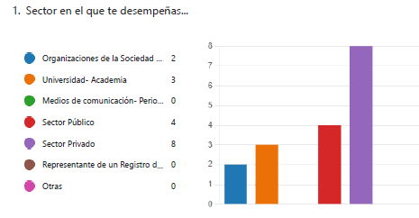

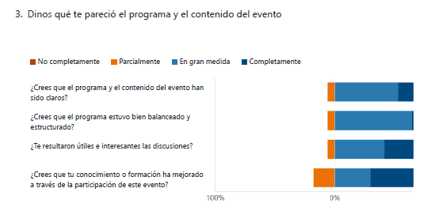
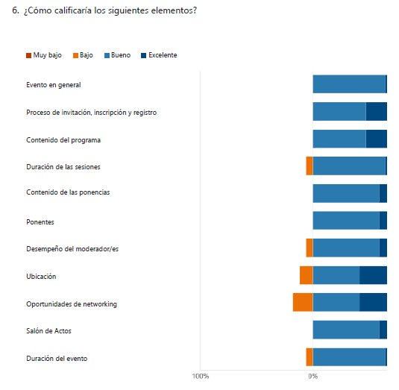

Annex V – Media outreach
Transparency International Spain has achieved a total of 17 media impacts, reaching an audience of 2.5 million and an economic communication value of 87,550 euros.
Expertos piden reforzar la transparencia sobre la propiedad de las…
MSN España - 28-09-2022
delitos económicos. - TRANSPARENCY INTERNATIONAL ESPAÑA Expertos ha reclamado un refuerzo de la transparencia y el acceso a la información relativa a la propiedad de las empresas para evitar un uso delictivo de las mismas, al tiempo que han insistido en la importancia de un registro central útil y transparente de titulares reales para prevenir el blanqueo de capitales y otros delitos económicos
URL | Texto | PDF

Transparency International España analiza el papel que juegan los registros de titulares reales centralizados
Lawyer Press - 28-09-2022
Transparency International España analiza el papel que juegan los registros de titulares reales centralizados Transparency International España analiza el papel que juegan los registros de titulares reales centralizados Publicado el miércoles, 28 septiembre 2022 Email Terminar con las estructuras corporativas opacas y las empresas fantasma se ha convertido en una prioridad de primer orden en la
URL | Texto | PDF

IRÁN: CONTEXTO POLÍTICO Y SOCIAL DE LAS PROTESTAS
Público.es - 27-09-2022
revelan la desastrosa situación económica del país: Irán ocupa el puesto 150 de 180 países en una encuesta de Transparencia Internacional sobre políticas anticorrupción. La renta per cápita del país ha crecido menos del 1% entre la revolución y hoy. Casi la mitad de los hogares iraníes viven por debajo del umbral de la pobreza. La tasa de inflación ha superado el 35% en los últimos tres años. Las importaciones de Irán se han reducido a la mitad en los últimos 10 años. Y el índice de confianza social, que había alcanzado casi el 70% en 1981, se ha reducido a cerca del 20% en el último año.
URL | Texto | PDF

Expertos piden reforzar la transparencia sobre la propiedad de las empresas para para evitar su uso delictivo
Europa Press - 27-09-2022
transparente de titulares reales para prevenir el blanqueo de capitales y otros delitos económicos. "Terminar con las estructuras corporativas opacas y las empresas fantasma se ha convertido en una prioridad de primer orden en la agenda mundial anticorrupción", han señalado los expertos en un seminario celebrado por Transparency International España, en colaboración con el Colegio de Registradores de Madrid
URL | Texto | PDF

Economía.- Expertos piden reforzar la transparencia sobre la propiedad de las empresas para para evitar su uso delictivo
Bolsamania - 27-09-2022
delitos económicos. Terminar con las estructuras corporativas opacas y las empresas fantasma se ha convertido en una prioridad de primer orden en la agenda mundial anticorrupción , han señalado los expertos en un seminario celebrado por Transparency International España, en colaboración con el Colegio de Registradores de Madrid, donde se han abordado los principales desafíos de los registros de
URL | Texto | PDF

Expertos piden reforzar la transparencia sobre la propiedad de las empresas para para evitar su uso delictivo
El Confidencial Digital - 27-09-2022
corporativas opacas y las empresas fantasma se ha convertido en una prioridad de primer orden en la agenda mundial anticorrupción", han señalado los expertos en un seminario celebrado por Transparency International España, en colaboración con el Colegio de Registradores de Madrid, donde se han abordado los principales desafíos de los registros de titulares reales. Para los expertos, es "clave" que
URL | Texto | PDF

Expertos piden reforzar la transparencia sobre la propiedad de las empresas para para evitar su uso delictivo | Estrategias de Inversión
Estrategias de Inversión - 27-09-2022
registro central útil y transparente de titulares reales para prevenir el blanqueo de capitales y otros delitos económicos. "Terminar con las estructuras corporativas opacas y las empresas fantasma se ha convertido en una prioridad de primer orden en la agenda mundial anticorrupción", han señalado los expertos en un seminario celebrado por Transparency International España, en colaboración con el
URL | Texto | PDF

Expertos piden reforzar la transparencia sobre la propiedad de las empresas para para evitar su uso delictivo |
Negocios.com - 27-09-2022
prevenir el blanqueo de capitales y otros delitos económicos. Terminar con las estructuras corporativas opacas y las empresas fantasma se ha convertido en una prioridad de primer orden en la agenda mundial anticorrupción, han señalado los expertos en un seminario celebrado por Transparency International España, en colaboración con el Colegio de Registradores de Madrid, donde se han abordado los
URL | Texto | PDF

Expertos piden reforzar la transparencia sobre la propiedad de las empresas para para evitar su uso delictivo
Diario Siglo XXI - 27-09-2022
titulares reales para prevenir el blanqueo de capitales y otros delitos económicos. "Terminar con las estructuras corporativas opacas y las empresas fantasma se ha convertido en una prioridad de primer orden en la agenda mundial anticorrupción", han señalado los expertos en un seminario celebrado por Transparency International España, en colaboración con el Colegio de Registradores de Madrid, donde se
URL | Texto | PDF

Los expertos insisten en la importancia de un registro central útil y transparente de titulares reales para prevenir el blanqueo de capitales y otros delitos económicos | Penal | LawAndTrends
Law&Trends - 27-09-2022
estándares a nivel europeo Transparency International España ha organizado un seminario en el que se han abordado los principales desafíos que plantea una implementación eficaz del registro de titularidades reales para prevenir la corrupción, el fraude y el blanqueo de capitales Terminar con las estructuras corporativas opacas y las empresas fantasma se ha convertido en una prioridad de primer
URL | Texto | PDF

Alcalá y Torrejón reciben el sello Infoparticipa de la Universidad de Barcelona
El Telescopio Digital - 27-09-2022
transparentes de España en el Índice de Transparencia de los Ayuntamientos (ITA) tanto en su edición de 2015 como de 2017. Un ranking elaborado por otra prestigiosa organización no gubernamental, Transparencia Internacional España, que medía el nivel de transparencia ante los ciudadanos y la sociedad de los 110 mayores Ayuntamientos del país. Ignacio Vázquez informó que "todos aquellos ciudadanos
URL | Texto | PDF

Expertos piden reforzar la transparencia sobre la propiedad de las empresas para para evitar su uso delictivo
pressdigital.es - 27-09-2022
central y abierto no sólo para autoridades y sujetos obligados, sino para toda la ciudadanía. "El intercambio de información y la colaboración entre las autoridades públicas son las principales experiencias y buenas prácticas en la materia, pero aún estamos lejos de cumplir con los mayores estándares a nivel europeo", han reiterado expertos del Consejo General del Notariado, el Colegio de Registradores, Transparency International, EITI, el SEPBLAC o funcionarios públicos de registros de otros países.
URL | Texto | PDF
JUSTICIA Los expertos urgen a crear el registro central para luchar contra el
El Ideal Gallego - 24-09-2022
JUSTICIA Los expertos urgen a crear el registro central para luchar contra el blanqueo del terrorismo Varios expertos urgieron ayer al Ministerio de Justicia a que implante cuanto antes el proyectado registro central de titulares reales de sociedades y otras entidades para avanzar en la lucha contra el blanqueo de capitales y la nanciación del terrorismo. Es una de las conclusiones de un seminario organizado por Transparencia Internacional y el Colegio de Registradores de España.
Recorte | TEXTO | Pag. Completa

JUSTICIA Los expertos urgen a crear el registro central para luchar contra el
Diario de Bergantiños - 24-09-2022
JUSTICIA Los expertos urgen a crear el registro central para luchar contra el blanqueo del terrorismo Varios expertos urgieron ayer al Ministerio de Justicia a que implante cuanto antes el proyectado registro central de titulares reales de sociedades y otras entidades para avanzar en la lucha contra el blanqueo de capitales y la nanciación del terrorismo. Es una de las conclusiones de un seminario organizado por Transparencia Internacional y el Colegio de Registradores de España.
Recorte | TEXTO | Pag. Completa

JUSTICIA Los expertos urgen a crear el registro central para luchar contra el
Diario de Ferrol - 24-09-2022
JUSTICIA Los expertos urgen a crear el registro central para luchar contra el blanqueo del terrorismo Varios expertos urgieron ayer al Ministerio de Justicia a que implante cuanto antes el proyectado registro central de titulares reales de sociedades y otras entidades para avanzar en la lucha contra el blanqueo de capitales y la nanciación del terrorismo. Es una de las conclusiones de un seminario organizado por Transparencia Internacional y el Colegio de Registradores de España.
Recorte | TEXTO | Pag. Completa

JUSTICIA Los expertos urgen a crear el registro central para luchar contra el
Diario de Arousa - 24-09-2022
JUSTICIA Los expertos urgen a crear el registro central para luchar contra el blanqueo del terrorismo Varios expertos urgieron ayer al Ministerio de Justicia a que implante cuanto antes el proyectado registro central de titulares reales de sociedades y otras entidades para avanzar en la lucha contra el blanqueo de capitales y la nanciación del terrorismo. Es una de las conclusiones de un seminario organizado por Transparencia Internacional y el Colegio de Registradores de España.
Recorte | TEXTO | Pag. Completa

Expertos urgen a crear el registro central para luchar contra el blanqueo - España
Cope - 23-09-2022
Ministerio de Justicia a que implante cuanto antes el proyectado registro central de titulares reales de sociedades y otras entidades para avanzar en la lucha contra el blanqueo de capitales y la financiación del terrorismo. Es una de las principales conclusiones de un seminario organizado por Transparencia Internacional y el Colegio de Registradores de España, en cuya inauguración su decana, María
URL | Texto | PDF

Annex VI –Short bios of the speakers
Beneficial Ownership Transparency in Spain: Towards a transparent
and meaningful national register of beneficial owners

Session 1 - Beneficial Ownership Transparency in Spain: Towards a transparent national register of beneficial owners
Moderator: Jesús Sánchez Lambás

Concepción Cornejo Garcia. Area Coordinator of the General Secretariat of Inspection and Control of Capital Movements of the Ministry of Economic Affairs and Digital Transformation. She belongs to the Senior Corps of Civil Administrators of the State, which she entered by competitive examination in 2003. Since then, he has worked in the Ministry of Justice and the Ministry of Foreign Affairs. Most of her professional career has been working (for 10 years) in the General Directorate of the Treasury on issues related to the prevention of money laundering. In this agency she was Deputy Assistant Director General in her first stage, and currently she is Area Coordinator. Among her main functions are:
- The drafting of regulations for this sector of activity.
- Attendance at EU and international forums (such as FATF) where international policies are discussed and subsequently implemented at the national level.
- The instruction of sanctioning proceedings in this area.

Belén Madrazo Meléndez has a law degree from the University of Zaragoza. Arbitrator of Law by the University Juan Carlos I of Madrid. Family, civil and commercial mediator. Property, Mercantile and Movable Property Registrar since 1988. Linked to the University of Zaragoza as associate professor in the Chair of Civil Law and professor in the area of commercial law in the school of legal practice. She teaches in the Faculty of Economics of Zaragoza a Master of specialization in Real Estate Law.
From 2009 to 2013 she was a member of the Governing Board of the Association of Registrars of Spain, being Director of Environment and Consumers and Users. In 2014 she was awarded the medal of honor of the Association of Registrars of Spain. In 2019 she was awarded by the Ministry of Justice the distinguished cross of first class San Raimundo de Peñafort. Author of numerous publications, she is since 2017 Academic Director of CIDERM (Ibero-American Course on Commercial Registry Law) organized by AECID ( Spanish agency for Ibero-American cooperation and development). She is part of the working group of the Association of Registrars of Spain that studies the prevention of money laundering.

Mariano García Fresno is a civil servant on leave of absence from the Technical Corps of the Treasury and the Executive Corps of Customs Surveillance. In 1985 he joined the Customs Surveillance Service as an Investigation Agent and until 9/02/2006 he was Head of Service of the Secretariat of the Commission for the Prevention of Money Laundering and representative of Spain in the Financial Action Task Force of South America (GAFISUD). He is currently assistant to the head of the Analysis and Communications Unit of the Centralized Body for the Prevention of Money Laundering of the General Council of Notaries. By Resolution of the Ministry of the Interior, dated September 20, 2010, he was awarded the Cross of Police Merit with white badge. By Resolution of the Ministry of the Interior, dated September 30, 2011, she was awarded the Silver Cross of the Order of Merit of the Civil Guard Corps.

Africa Pinillos is Head of the Supervision Area of Sepblac, the Spanish anti-money laundering authority, since April 2021 and an expert in AML/CFT. The Supervision Area of Sepblac defines Sepblac's strategy and plans for supervision and national and international cooperation with other supervisory and regulatory authorities. He worked in the Legal Department of the Bank of Spain as Legal Counsel for 13 years, with a 5-month stay in the Legal Services of the European Central Bank in 2006. At the end of 2013 he joined Sepblac in the Financial Intelligence area and in 2015 he joined the Coordination of Supervision and Inspection. For the last 8 years he has been participating in various European and international AML/CFT working groups, committees and forums that have been developing supervisory rules and standards, highlighting his active participation in the work of the EBA. He is also a member of the EBA's network of national AML/CFT experts, which has assessed the AML/CFT supervisory systems of several European Union countries. He participates in various national and international training forums on AML/CFT matters.

Session 2 - Beneficial Ownership Transparency in Europe: advanced comparative experiences of national registries
Moderator: François Valérian

Alexander Peschetz is head of Department III/12, BORA Registry Authority in the Federal Ministry of Finance and an expert in money laundering prevention. He was responsible for the implementation of the 4th and 5th Money Laundering Directive for the financial market (FM-GwG) and the Beneficial Owner Register Act (WiEReG). He is also a lecturer and author of numerous specialist publications.

Marco Vianello is the International Advisor of InfoCamere (infocamere.it), the IT Consortium of the Italian Chambers of Commerce. Born in Padua, Marco Vianello has a degree in Economic and Business from Venice University. As an expert in marketing and network telecommunications, he spent his career first in the large-scale retail trade working for Vision Express UK (General Manager based in London), then within the Italian Chambers' System contributing to set up, implement and develop the Italian Business Register, internationally acknowledged as a best practice in eGovernment solutions.He is one of the major expert in data and information provided by the Italian Business Register. Also he is a Founding Board Member of EBRA – European Business Register Association (ebra.be), the international organization of Business Registry professionals that provides insight to Business Registry policy, operations and technology initiatives.

Yves Gonner is the Managing Director of Luxembourg Business Registers, which since 2019 manages the country’s Register of Beneficial Owners. He has gathered extensive experience over the last 30 years, as an Economic counsellor at the Chamber of Commerce of Luxembourg and Secretary General to the National Export Credit Insurance Agency, as well as in different management positions at a major bank in Luxembourg. He is currently member of the board and treasurer of the European Business Registry association (EBRA).

Session 3 - Anti-corruption activism for improving Beneficial Ownership Transparency standards
Moderator: Christoph Kowalewsk

Maíra Martini is the Research and Policy Expert on corrupt money flows at the Transparency International Secretariat in Berlin (TI-S) and leads the TI movement work on illicit financial flows, anti-money laundering, and beneficial ownership transparency. She is the author of several TI reports on these issues. Maíra is part of the Global Anti-Corruption Consortium, a ground-breaking partnership with investigative journalists from the Organized Crime and Corruption Reporting Project. She is also on the Steering Groups of OpenOwnership and the Anti-Corruption Data Collective. Prior to that, Maira worked on the Anti-Corruption Helpdesk, where she produced research briefs on anti-corruption and governance on a variety of issues and countries and led the establishment of TI’s Anti-Corruption Experts Network. Maira is a lawyer, a certified anti-money laundering specialist (CANS) and holds a Masters in public policy from the Hertie School of Governance in Berlin.

Lucia Cirimello is Programme Manager of Opening Extractives, a five year programme delivered by the Extractive Industries Transparency Initiative (EITI) in partnership with Open Ownership, and funded by the BHP Foundation. Opening Extractives is an ambitious global programme aimed at catalysing the availability and use of beneficial ownership data across 10 countries. The programme combines political engagement and technical assistance to participating countries to implement reforms on beneficial ownership disclosure.

Daniele Grasso is an Italian Data Journalist based in Madrid. He is highly experienced on bringing data-driven answers to issues that require to analyze a great amount of information. He is passionate about digital innovation and teamwork. He currently coordinates the Data Journalism Unit at the Spanish leading newspaper, El País. He is a member of the International Consortium of Investigative Journalists (ICIJ) and he played a leading role in the Spanish chapters of cross-border investigations 'Lux Leaks', 'Swiss Leaks' and the Pulitzer winning investigation known as The Panama Papers.

Annex VII – Photos




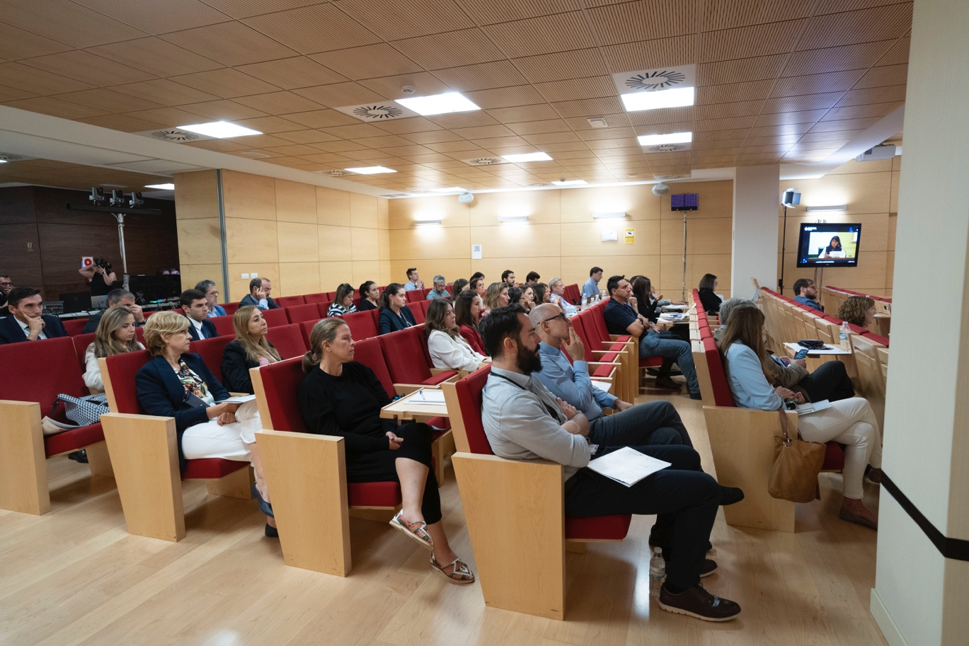
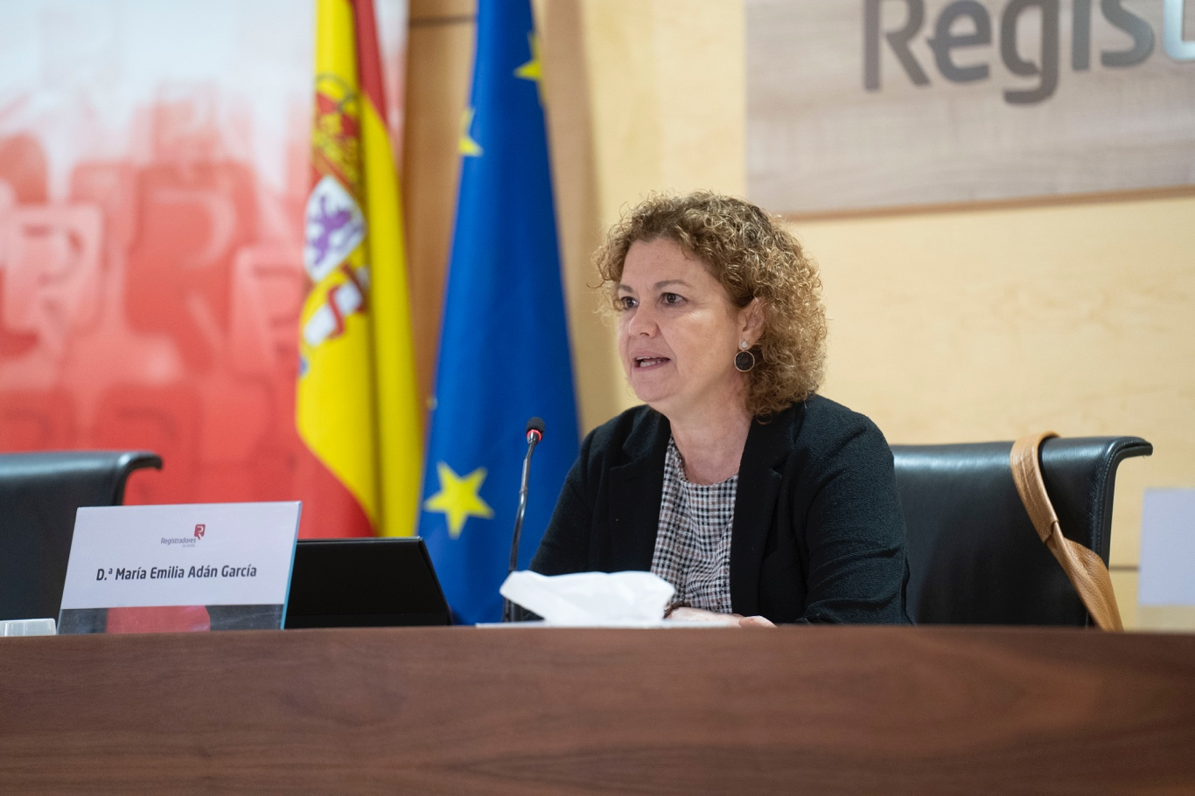
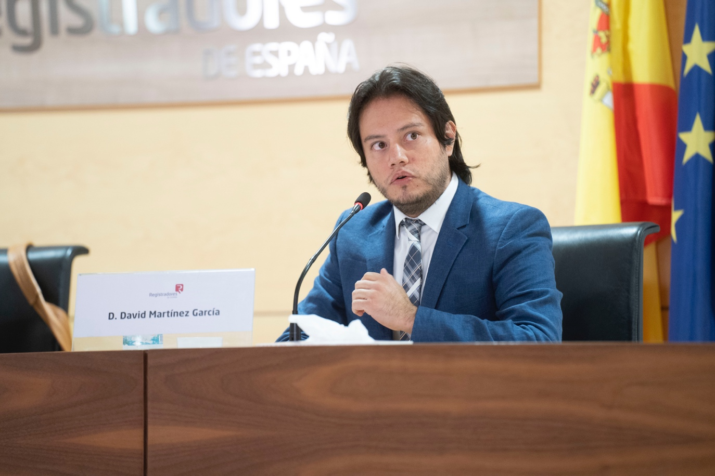

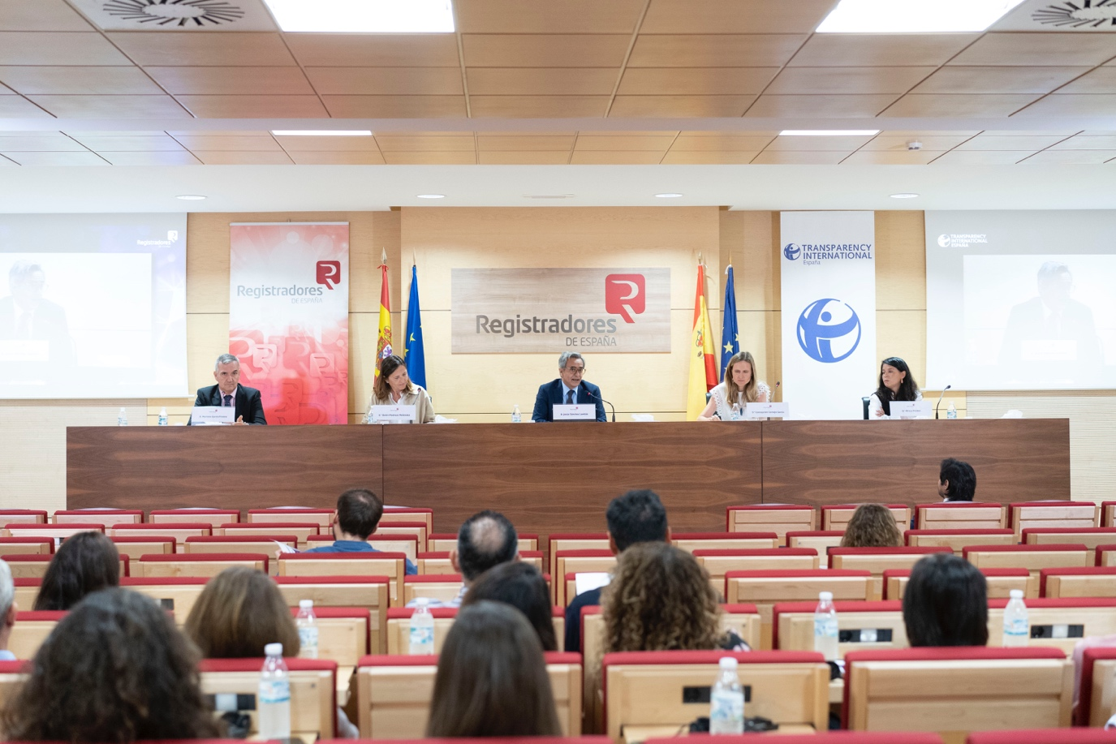
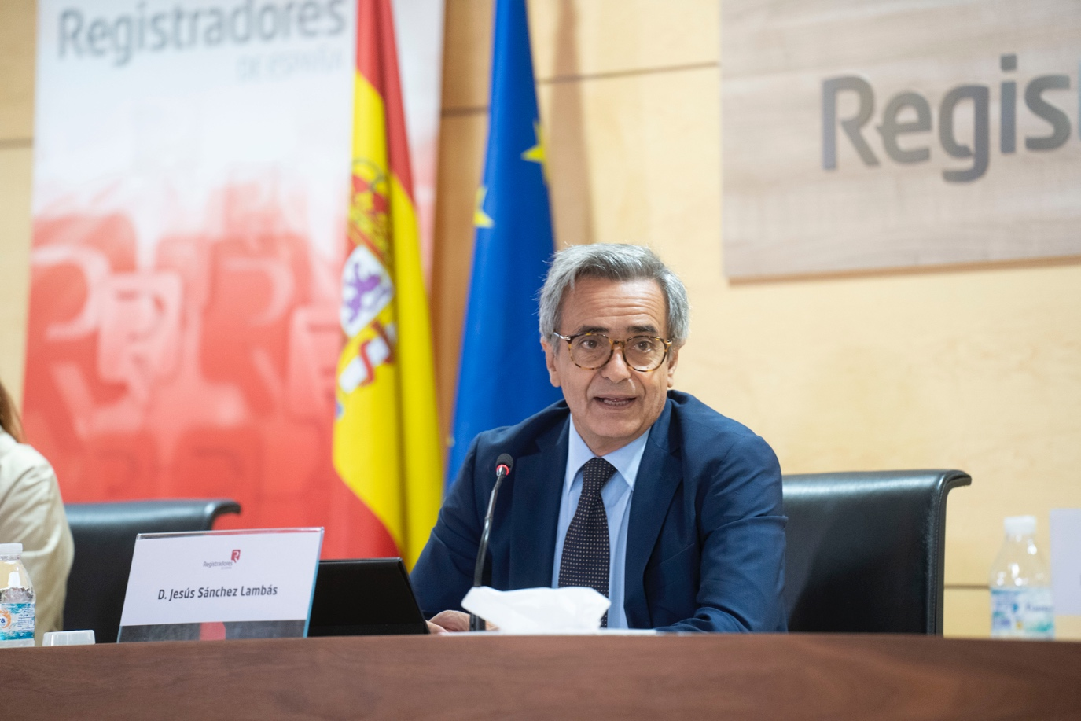
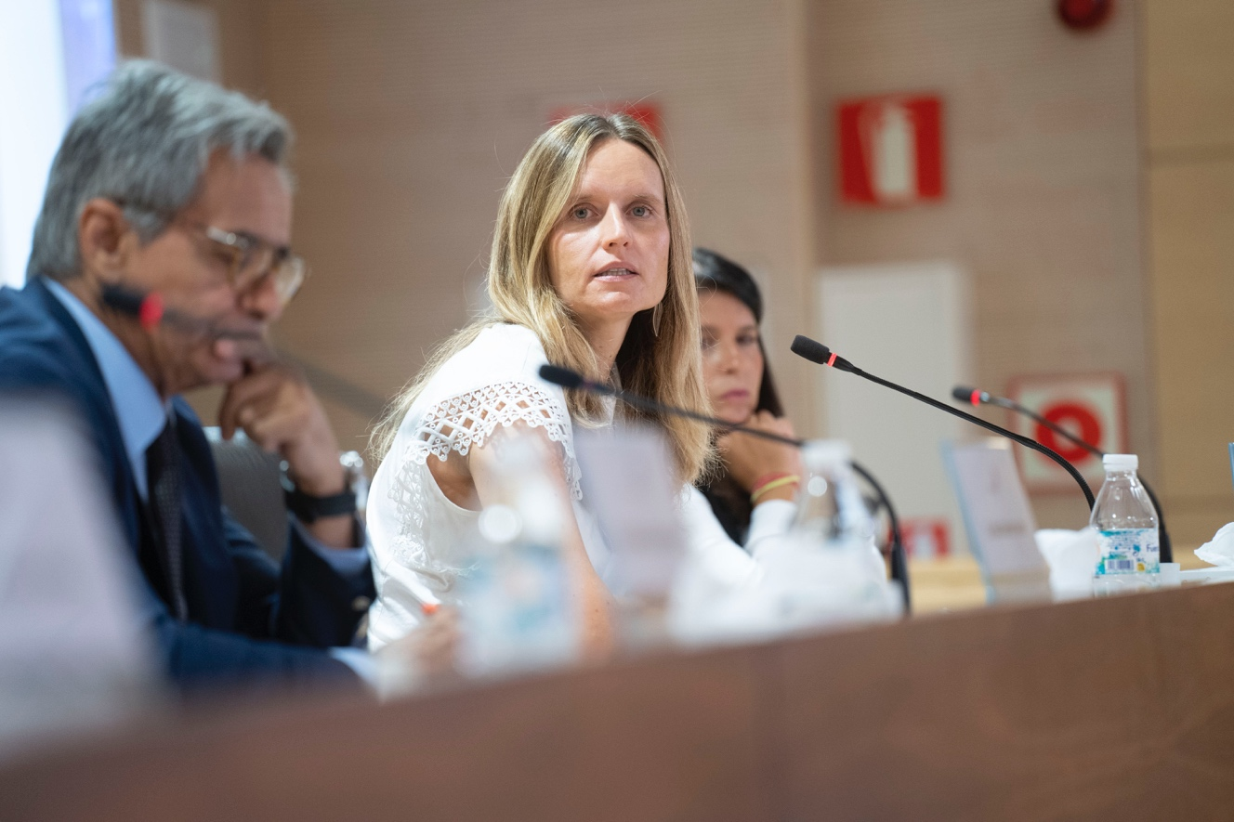
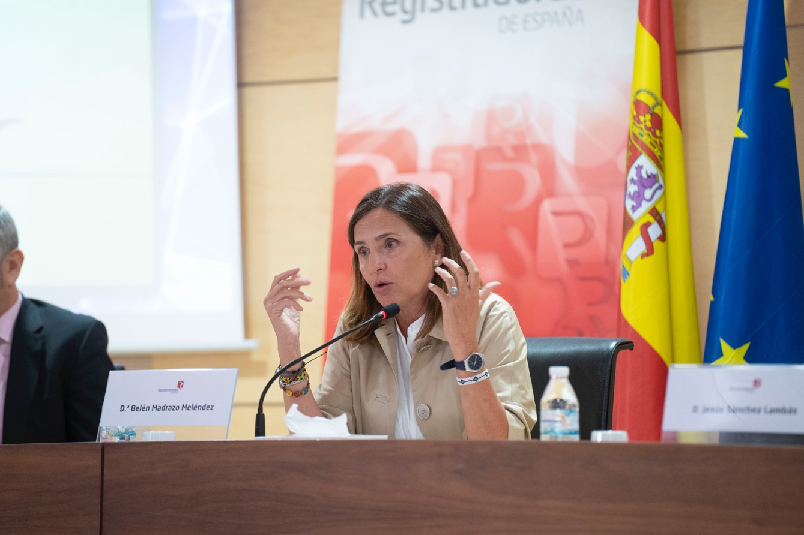

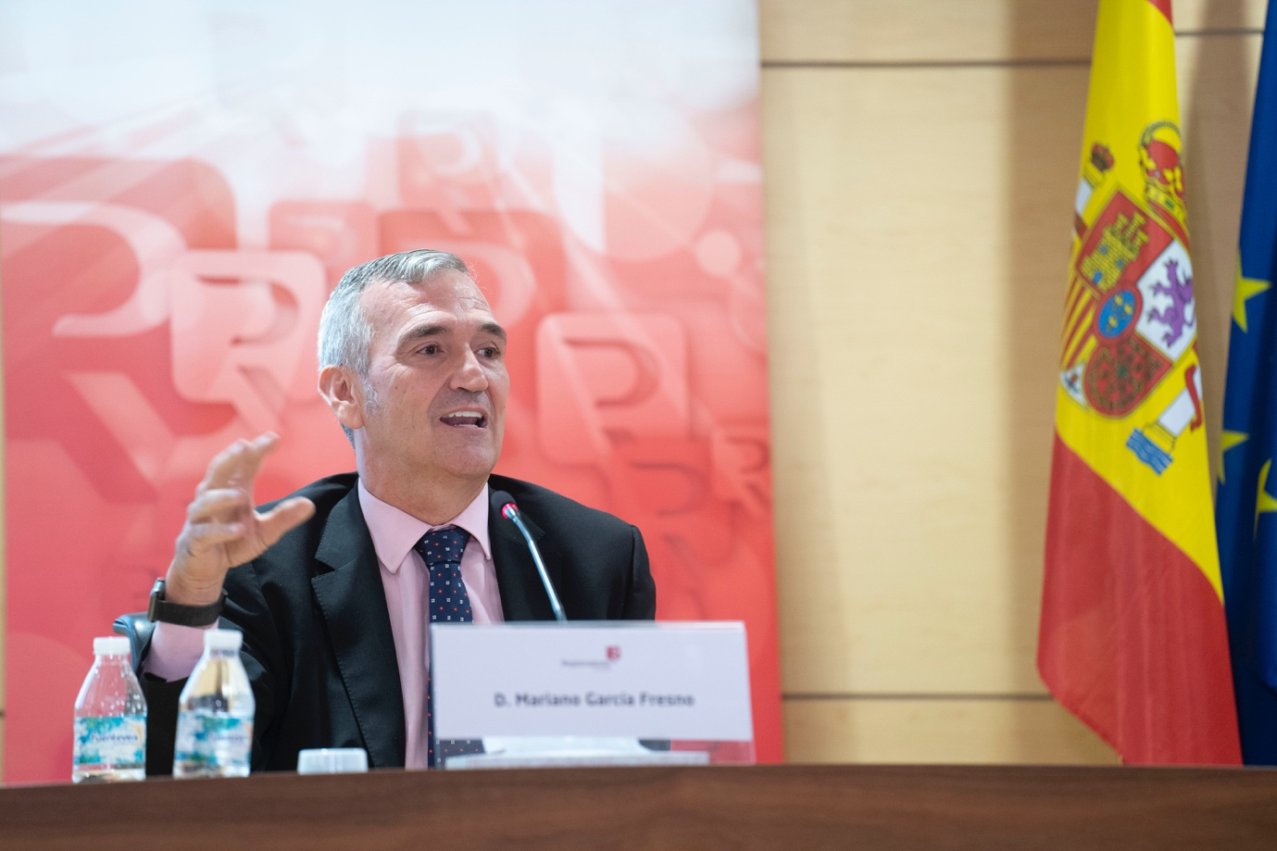
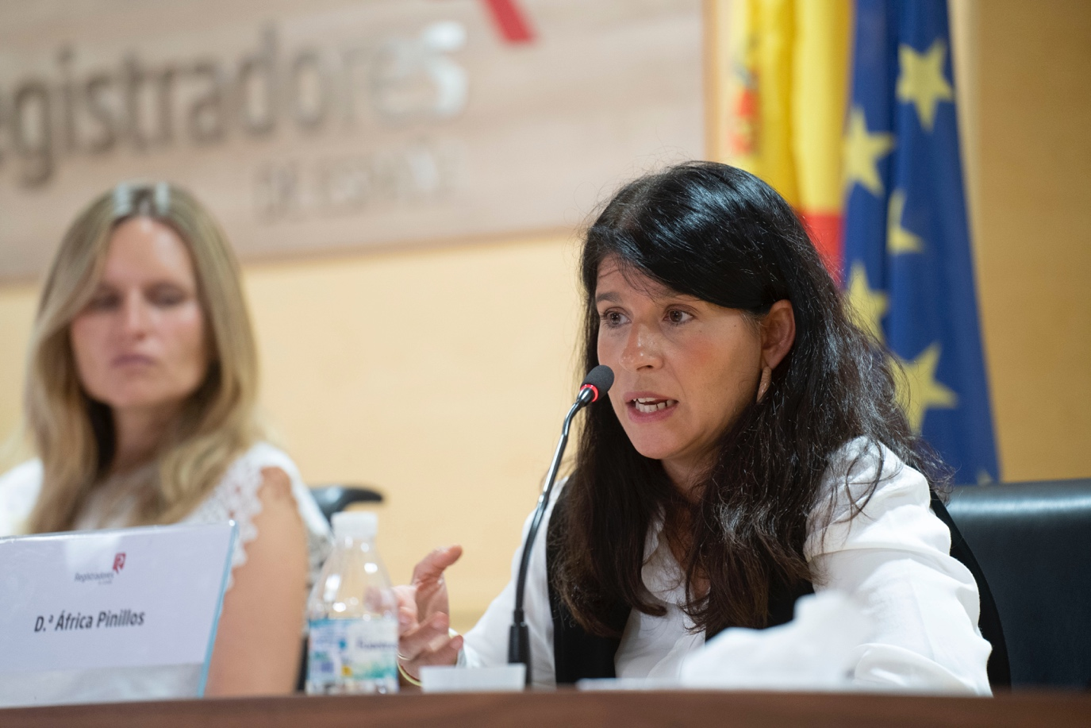

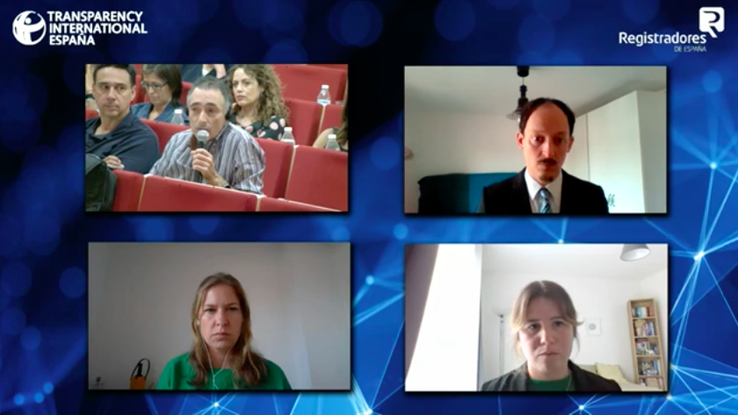
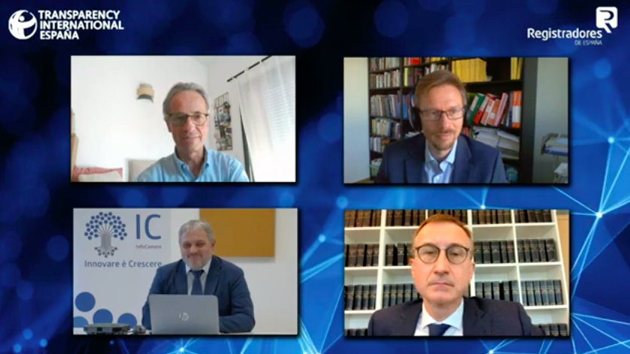

Contact:
csabotproject@transparency.org

This represents an attendance rate of 74,4%, which in the midst of the post pandemic period, represents a very high percentage of attendance in relation to the registrations.
See Annex V

